

MGT1022 - Lean Startup Management

**J Component Report**

**EcoSort:**

**Intelligent Recycling Solution**

**Guided by-** Dr. KAMACHI R

**Group 8**

|  |  |
| --- | --- |
| MYLIE MUDALIYAR | 20BCE2661 |
| SWETA CHANDRASEKHAR | 20BCE2625 |
| GOKUL.U | 22MIS0291 |
| ROSHAN PRIYAN V.S | 22MIS0278 |
| CHETAN KRISHNA | 20BCE0338 |
| DARSHAN YAKILA | 20BCE0375 |
| CHITTALA NAVEEN | 20BCE0383 |

|  |  |
| --- | --- |
| **Content** | **Page No** |
| **Introduction** | **3** |
| **Problem Statement** | **3** |
| **Literature Survey** | **4** |
| **Key Challenges / Gap** | **6** |
| **Target Audience** | **6** |
| **Startup Logo** | **7** |
| **Working Methodology** | **7** |
| **Application** | **10** |
| **General Public Feedback** | **12** |
| **Conclusion** | **14** |
| **Future Scope** | **14** |
| **Reference** | **15** |

**Introduction**

The global waste crisis, characterized by the annual generation of over 2 billion tonnes of municipal solid waste worldwide, poses a severe challenge to both public health and the environment. Conventional recycling methods struggle to cope with the rising waste volumes, resulting in low recycling rates and persistent contamination issues. Enter EcoSort™, a visionary startup that harnesses cutting-edge technologies, including artificial intelligence (AI), computer vision, robotics, and IoT sensors, to revolutionize waste sorting and significantly boost recycling efficiency.

EcoSort™ leverages the capabilities of artificial intelligence (AI) and computer vision to revolutionize waste sorting. AI algorithms, fueled by massive datasets of waste materials, have been meticulously developed to recognize and categorize different materials in real-time. Whether it's distinguishing between plastics, metals, paper, or glass, the system excels with unerring precision. The integration of computer vision allows for the identification of items based on visual attributes, enabling the system to make split-second decisions during the sorting process.

EcoSort™ is a dynamic solution, with a commitment to continuous improvement. It actively solicits feedback, collects data, and refines its algorithms to adapt to changing waste streams and environmental challenges. This commitment to evolution ensures that the system remains at the forefront of recycling technology, always striving to be more efficient and effective.

Moreover, the scalable design of the system allows for its implementation in a variety of settings, from small community facilities to large urban centers. It is a versatile solution, designed to meet the unique needs of diverse waste management facilities.

**Problem Statement**

The global waste crisis, characterized by the annual generation of over 2 billion tonnes of municipal solid waste, poses a critical environmental and sustainability challenge. Conventional recycling methods and waste management practices are struggling to cope with the rapidly increasing waste volumes, resulting in low recycling rates and persistent contamination issues. These challenges not only hinder environmental conservation but also contribute to public health concerns and escalating pollution and greenhouse gas emissions from overflowing landfills. The need for an innovative and automated waste sorting solution that can significantly improve recycling efficiency and minimize contamination is evident.

**Literature Survey**

|  |  |
| --- | --- |
| Paper | Summary |
| A Novel YOLOv3 Algorithm-Based Deep Learning Approach for Waste Segregation: Towards Smart Waste Management | The study focuses on addressing environmental concerns caused by pollution and imbalanced ecosystems. With the rise of smart cities, there's a need for efficient waste management. The research introduces a novel waste segregation method using deep learning, particularly YOLOv3 algorithm in the Darknet framework. |
| A review of waste management practices and their impact on human health by L Giusti | The research reviews recent global waste generation and disposal trends, focusing on municipal solid waste (MSW). It examines waste management's potential health impacts, including bioaerosol exposure from composting and pathogen exposure from sewage treatment. The study evaluates various health outcomes among waste facility workers and nearby residents |
| A review and framework for understanding the potential impact of poor solid waste management on health in developing countries by Abdhalah K. Ziraba, Tilahun Nigatu Haregu & Blessing Mberu | This study addresses the challenge of inadequate solid waste management in Africa,where increased waste generation hasn't been matched with proper handling capacity. Less than 30% of urban waste in developing countries is appropriately managed. The research aims to establish a framework that explains how poor waste management leads to health issues. The framework considers waste nature, exposure, duration, and interventions. |
| The wicked problem of waste management: An attention-based analysis of stakeholder behaviours by Giuseppe Salvia a, Nici Zimmermann, Catherine Willan, Joanna Hale, Hellen Gitau, Kanyiva Muindi, Evans Gichana,Mike Davies | This article addresses the global issue of increasing waste, especially in lower-income countries, and its negative impact on health and the environment. Despite various policies and programs, progress has been limited due to the complexity of waste management as a "wicked problem," characterized by intricate interdependencies and various stakeholders. The study focuses on what captures the attention of stakeholders and decision-makers using the attention-based view from organization theory. |
| A Literature Review on Solid Waste Management: Characteristics, Techniques, Environmental Impacts and Health Effects in Aligarh City”, Uttar Pradesh, India” by Harit Priyadarshi, Sarv Priya, Ashish Jain & Shadab Khursheed | India is densely populated and ranks as the second most populous country globally, with approximately 1.37 billion people in 2019. The management of Municipal Solid Waste (MSW) in India faces challenges due to factors like rapid population growth, urbanization, commercialization, and industrialization. This paper examines waste characteristics, techniques, environmental impacts, health risks, and problems associated with municipal solid waste management. The study highlights issues like lack of concern, inadequate facilities, insufficient space for waste collection. |
| A Novel Strategy for Waste Prediction Using Machine Learning Algorithm with IoT Based Intelligent Waste Management System by G. Uganya, Rajalakshmi, Yuvaraja Teekaraman, Ramya Kuppusamy, Arun Radhakrishnan | The Internet of Things (IoT) is emerging as a crucial technology for advancing smart cities, but rapid urbanization and industrial growth lead to increased waste generation.The main objective is to minimize negative impacts of waste on the environment and human health, while also considering cost and resource management. This study proposes an IoT-based waste management system that predicts waste generation possibilities. IoT-connected bins continuously monitor wastage capacity, gas, and metal levels, enabling effective waste collection. |

**Key Challenges / Gap in Literature Review**

**Waste Volume and Diversity:** Managing the vast and diverse volume of municipal solid waste presents a significant challenge. The system must efficiently process a wide range of materials, from plastics to metals, paper, glass, and more.

**Contamination:** Contaminated items in the waste stream can disrupt the recycling process. The system must accurately detect and divert these items to minimize the impact of contamination on recycling quality.

**Technology Integration**: Integrating complex technologies like artificial intelligence, computer vision, robotics, and IoT sensors into a seamless and reliable system can be technically challenging. Ensuring these components work together harmoniously is essential.

**Data Management and Analytics:** Handling and analyzing the vast amounts of data generated by IoT sensors and computer vision systems require robust data management and analytics capabilities. This is crucial for optimizing the sorting process and improving efficiency.

**Operator Training:** Training operators and facility personnel to use and maintain the system effectively is essential. The success of the system depends on knowledgeable and skilled operators who can respond to any issues that arise during operation.

**Scalability:** Designing the system to be scalable is important to ensure it can be adapted to different facility sizes and waste volumes. It must be flexible enough to meet the unique needs of diverse waste management facilities.

**Public Awareness and Acceptance:** Raising public awareness about the benefits of intelligent recycling and gaining public acceptance for new waste management technologies can be challenging. Public perceptions and behavior can significantly impact the success of the system.

**Target Audience**

* **Waste Management Companies:** These companies play a central role in waste collection and processing. EcoSort™ offers the potential to significantly improve recycling rates, reduce operational costs, and enhance the sustainability of their waste management services.
* **Municipalities and Local Governments:** Municipalities are responsible for waste management and environmental policies. They have a direct interest in EcoSort™ as it can help them achieve recycling goals, reduce landfill usage, and minimize the environmental impact of waste disposal.
* **Recycling Facilities:** Recycling facilities, involved in sorting and processing recyclable materials, are crucial for ensuring the efficiency and quality of the recycling process. EcoSort™ can enhance their operations by reducing contamination and increasing the yield of recyclable materials.
* **Environmental Organizations:** Non-profit environmental organizations are dedicated to promoting sustainable waste management practices and reducing environmental pollution. EcoSort™ aligns with their mission and can serve as a valuable tool to further their environmental objectives.

**Feedback From Genera Public**

**Startup Logo**

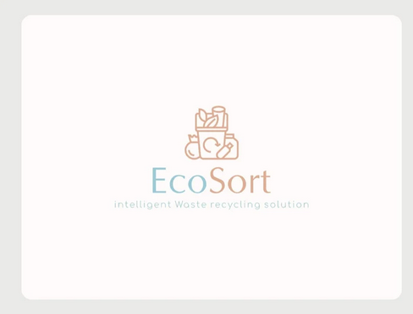

Figure 3. EcoSort Logo

**Methodology**

Our system uses state-of-the-art deep learning computer vision techniques to automatically classify and sort waste items. A camera captures live video of waste items placed in front of it. This video feed is processed in real-time by a deep neural network model trained to identify different waste types like plastic, paper, metal, glass etc.

Convolutional Neural Networks (CNNs) are the most prevalent algorithm utilized for image and visual recognition problems. CNN architectures like ResNet and Inception Net leverage convolutional layers to extract meaningful features from images. These layers detect visual patterns in the pixel data that can distinguish between classes like plastic, paper, and metal.

**Training Dataset**

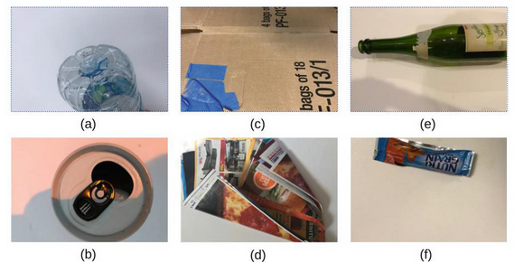

Figure 2. Sample images of TrashNet dataset, (a): plastic; (b): metal; (c): cardboard; (d): paper; (e): glass; and (f): general trash.

The TrashNet dataset is the only found annotated public recycling waste image dataset, and most recycling waste classification projects are based on this dataset, which contains 2527 images across six waste types (plastic, metal, cardboard, paper, glass, and general trash). These images are taken using iPhones with a white posterboard as the background under sunlight or room light. On the other hand, a private waste image dataset, called VN-Trash, contains 5904 images across three classes, including organic, inorganic, and medical waste.

In operation, the optimized waste classification CNN model evaluates each video frame captured by the camera. It identifies distinguishing features in the image like colors, shapes, text, surface properties that characterize different waste types. By comparing these visualized patterns to the learned weights in the convolutional layers, the network can predict the probability of each waste class. An overlay of the appropriate recycling bin is used to indicate the detected waste type for automatic sorting. The deep neural network provides the intelligence to power this real-world computer vision application.

By leveraging this AI-powered automated classification, we aim to greatly improve the efficiency, accuracy and speed of waste processing compared to human manual sorting. The system can continuously process a stream of waste items without fatigue.

Our smart waste sorting solution has numerous benefits:

* Improves recycling rates by accurate waste segregation
* Increases throughput and reduces operating costs for waste management
* Provides real-time tracking of waste metrics and analytics
* Requires minimal human intervention except collecting sorted waste
* Is scalable to large waste processing volumes or facility sizes

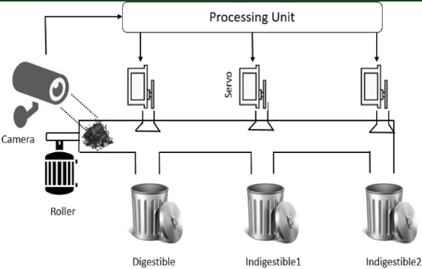

Figure 1. A block diagram of the proposed smart system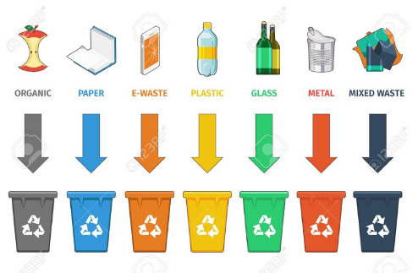

Figure 2. Output of the smart system (external view)

**Application**

Figure 3. User Interface of the Software

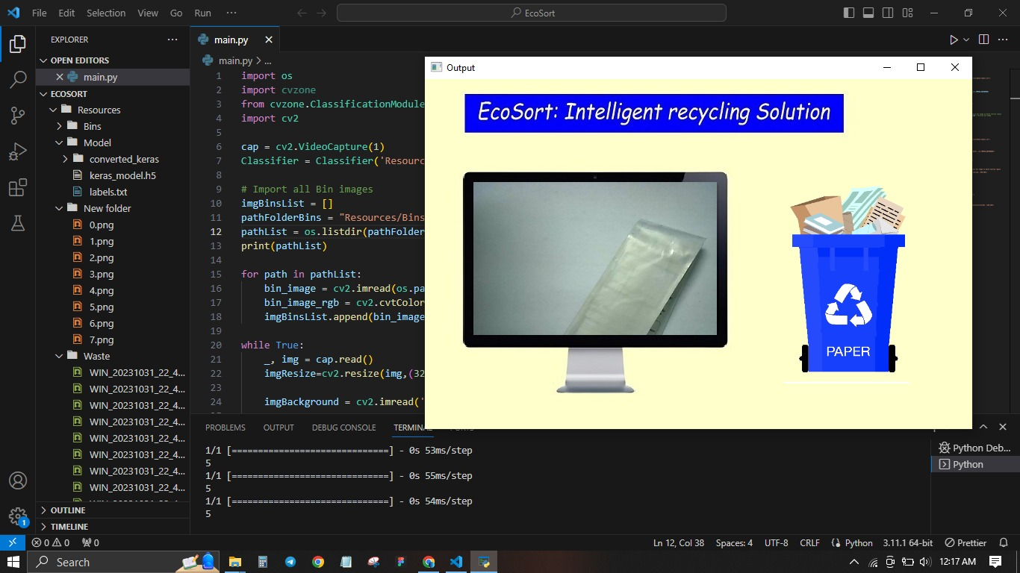

Figure 4. Detecting Paper

Figure 5. Detecting Glass

Figure 6. Detecting Hazardous Waste

Figure 7. Detecting Plastic

**General Public Feedback**

https://in.docworkspace.com/d/sIKz1xtS6Ab2xrKgG?sa=e1&st=0t

This survey effectively captures insights into recycling participation levels and identifies key challenges faced by respondents. Understanding the demographics and context of the survey would be helpful to assess its overall reliability and relevance. Additionally, the survey findings suggest areas where initiatives and policies can be targeted to improve recycling rates and sustainability efforts.

1. **On a scale of 1 to 5, how concerned are you about environment al issues related to waste management?**

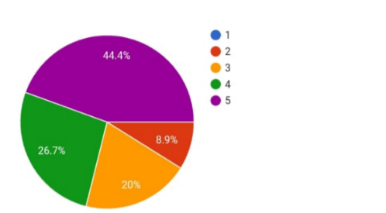

1. **How often do you participate in recycling programs or sort your waste for recycling?**

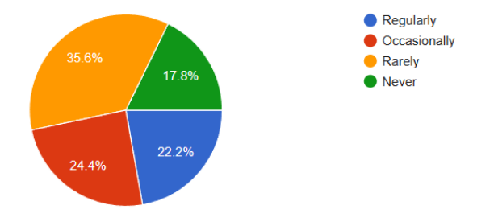

1. **What challenges do you face when sorting waste for recycling?**

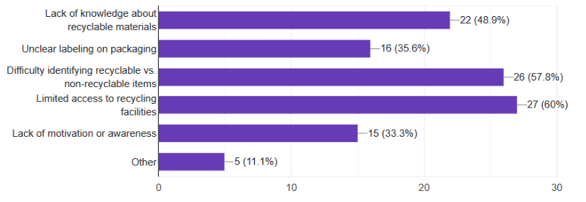

1. **Would you be willing to support or use a technology like EcoSort™ to enhance waste management practices in your community?**

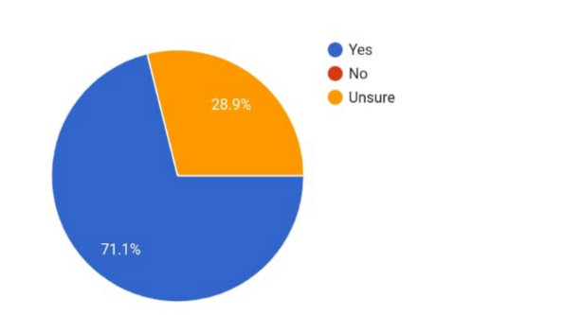

1. **What factors would influence your decision to support or use such a technology?**

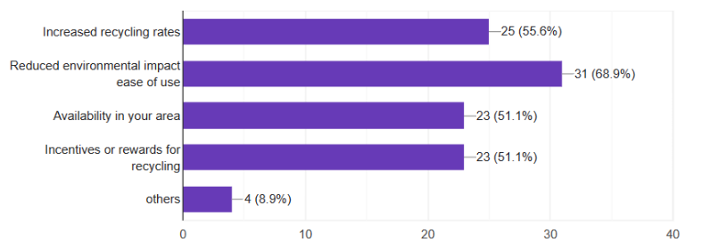

**Conclusion**

Our intelligent waste sorting system powered by deep learning provides an innovative AI-based solution that can transform waste management operations. It offers significant benefits aligned with sustainability priorities for smart cities of the future. Our AI-powered automated waste classification system aligns with smart city and sustainability initiatives to enhance recycling, reduce waste processing costs, and minimize environmental impact. This demonstrates how applied artificial intelligence can solve complex real-world problems like efficient waste management.

The outcome is an intelligent, automated waste processing system that can rapidly identify and sort different waste types into appropriate recycling streams. This has huge potential to make waste sorting more efficient, economical, and environmentally friendly using the power of AI. Our system is a futuristic solution to handle ever-increasing waste volumes and achieve sustainability goals.

**Future Scope**

The top two areas of future scope for EcoSort™: Intelligent Recycling Solution are technological advancements and global expansion. Continuous research and development in AI, computer vision, and IoT technologies will enhance system efficiency and adaptability. Furthermore, expanding the technology's reach to address the escalating global waste crisis and tapping into emerging markets will be key to its future success and influence in the waste management and recycling industry.

In addition to technological advancements and global expansion, the future scope also includes strengthening collaborations with environmental organizations and industry stakeholders. Building partnerships with these entities can help promote the widespread adoption of intelligent recycling solutions and advance environmental sustainability on a larger scale. These collaborations will play a pivotal role in shaping the future of EcoSort™ and its contribution to more responsible waste management practices.

**References**

* LeCun, Y., Bottou, L., Bengio, Y., & Haffner, P. (1998). Gradient-based learning applied to document recognition. Proceedings of the IEEE, 86(11), 2278-2324. - seminal CNN paper
* He, K., Zhang, X., Ren, S., & Sun, J. (2016). Deep residual learning for image recognition. In Proceedings of the IEEE conference on computer vision and pattern recognition (pp. 770-778). - ResNet architecture
* Tan, C., Sun, F., Kong, T., Zhang, W., Yang, C., & Liu, C. (2018). A survey on deep transfer learning. In Artificial neural networks and machine learning-ICANN 2018 (pp. 270-279). Springer, Cham. - transfer learning survey
* OpenCV Documentation - <https://docs.opencv.org/3.4/d6/d00/tutorial_py_root.html>
* Keras Documentation - <https://keras.io>
* TensorFlow Documentation - <https://www.tensorflow.org/overview>
* Waste classification using deep learning - <https://www.mdpi.com/2076-3417/10/3/771>
* Automated waste segregation system - <https://ieeexplore.ieee.org/abstract/document/8424831/>
* Computer vision for waste handling - <https://dl.acm.org/doi/10.1145/3394486.3407396>